**ARYAMAN MISHRA**

**19BCE1027**

**FIREWALL CONFIGURATIONS**

UFW (**u**ncomplicated **f**ire**w**all) is a firewall configuration tool that runs on top of iptables, included by default within Ubuntu distributions. It provides a streamlined interface for configuring common firewall use cases via the command line.

Execute following commands:

apt-get update

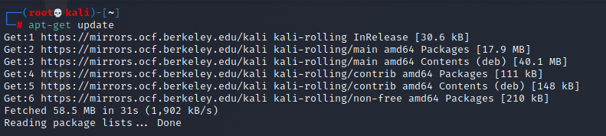

apt-install ufw

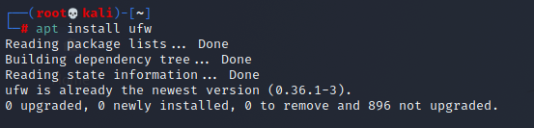

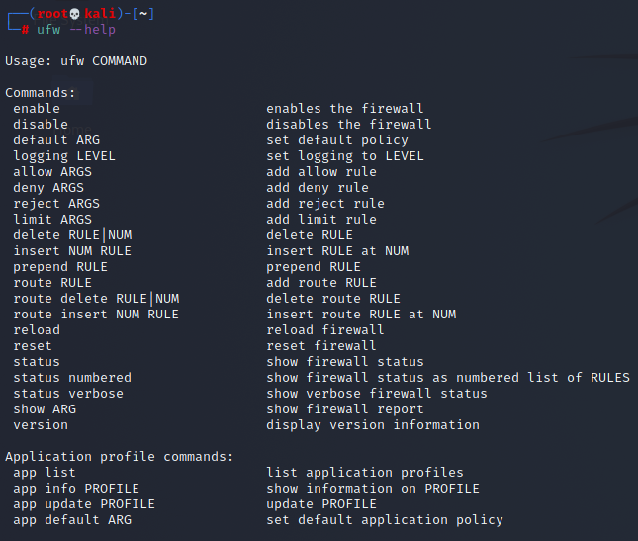

Delete UFW Rule

To delete a rule that you previously set up within UFW, use ufw delete followed by the rule (allow or deny) and the target specification. The following example would delete a rule previously set to allow all connections from an IP address of 203.0.113.101:

sudo ufw delete allow from 203.0.113.101

Rule deleted

Another way to specify which rule you want to delete is by providing the rule ID. This information can be obtained with the following command:

sudo ufw status numbered

Status: active

To Action From

-- ------ ----

[ 1] Anywhere DENY IN 203.0.113.100

[ 2] Anywhere on eth0 ALLOW IN 203.0.113.102

From the , you can see that there are two active rules. The first rule, with highlighted values, denies all connections coming from the IP address 203.0.113.100. The second rule allows connections on the eth0 interface coming in from the IP address 203.0.113.102.

Because by default UFW already blocks all external access unless explicitly allowed, the first rule is redundant, so you can remove it. To delete a rule by its ID, run:

sudo ufw delete 1

You will be prompted to confirm the operation and to make sure the ID you’re providing refers to the correct rule you want to delete.

Deleting:

deny from 203.0.113.100

Proceed with operation (y|n)? y

Rule deleted

If you list your rules again with sudo ufw status, you’ll see that the rule was removed.

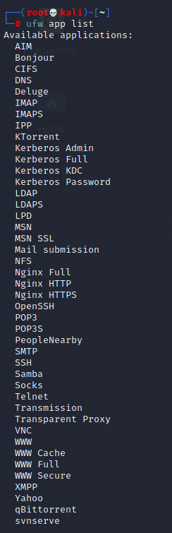

sudo ufw status

Verify UFW Status

To check if ufw is enabled, run:

* sudo ufw status

Status: inactive

The will indicate if your firewall is active or not.



ufw status verbose

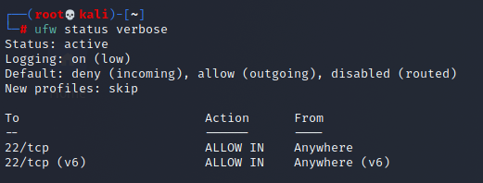

sudo ufw status numbered

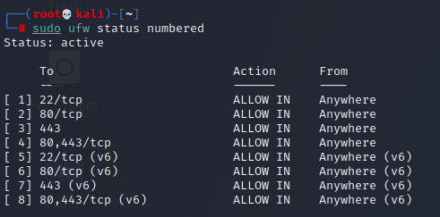

ufw enable

Enable UFW

If you got a Status: inactive message when running ufw status, it means the firewall is not yet enabled on the system. You’ll need to run a command to enable it.

By default, when enabled UFW will block external access to all ports on a server. In practice, that means if you are connected to a server via SSH and enable ufw before allowing access via the SSH port, you’ll be disconnected. Make sure you follow the section on [how to enable SSH access](https://www.digitalocean.com/community/tutorials/ufw-essentials-common-firewall-rules-and-commands) of this guide before enabling the firewall if that’s your case.

To enable UFW on your system, run:

sudo ufw enable

You’ll see like this:

Firewall is active and enabled on system startup

To see what is currently blocked or allowed, you may use the verbose parameter when running ufw status, as follows:

* sudo ufw status

Status: active

Logging: on (low)

Default: deny (incoming), allow (outgoing), deny (routed)

New profiles: skip

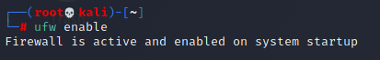

ufw reset

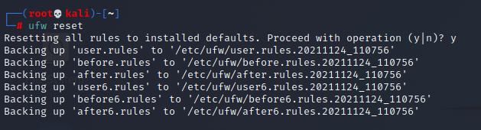 Disable UFW

If for some reason you need to disable UFW, you can do so with the following command:

sudo ufw disable

Be aware that this command will fully disable the firewall service on your system.

Block an IP Address

To block all network connections that originate from a specific IP address, run the following command, replacing the highlighted IP address with the IP address that you want to block:

sudo ufw deny from 203.0.113.100

Rule added

In this example, from 203.0.113.100 specifies a **source** IP address of “203.0.113.100”.

If you run sudo ufw status now, you’ll see the specified IP address listed as denied:

Status: active

To Action From

-- ------ ----

Anywhere DENY 203.0.113.100

All connections, coming in or going out, are blocked for the specified IP address.

Block a Subnet

If you need to block a full subnet, you may use the subnet address as from parameter on the ufw deny command. This would block all IP addresses in the example subnet 203.0.113.0/24:

sudo ufw deny from 203.0.113.0/24

Rule added

Block Incoming Connections to a Network Interface

To block incoming connections from a specific IP address to a specific network interface, run the following command, replacing the highlighted IP address with the IP address you want to block:

sudo ufw deny in on eth0 from 203.0.113.100

Rule added

The in parameter tells ufw to apply the rule only for **incoming** connections, and the on eth0 parameter specifies that the rule applies only for the eth0 interface. This might be useful if you have a system with several network interfaces (including virtual ones) and you need to block external access to some of these interfaces, but not all.

Allow an IP Address

To allow all network connections that originate from a specific IP address, run the following command, replacing the highlighted IP address with the IP address that you want to allow access:

sudo ufw allow from 203.0.113.101

Rule added

If you run sudo ufw status now, you’ll see similar to this, showing the word ALLOW next to the IP address you just added.

Status: active

To Action From

-- ------ ----

...

Anywhere ALLOW 203.0.113.101

You can also allow connections from a whole subnet by providing the corresponding subnet mask for a host, such as 203.0.113.0/24.

sudo ufw default deny incoming

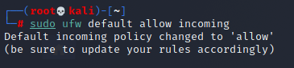

sudo ufw default allow outgoing

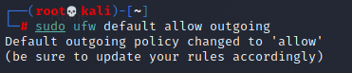

sudo ufw allow ssh

Allow SSH

When working with remote servers, you’ll want to make sure that the SSH port is open to connections so that you are able to log in to your server remotely.

The following command will enable the OpenSSH UFW application profile and allow all connections to the default SSH port on the server:

* sudo ufw allow OpenSSH

Rule added

Rule added (v6)

Although less user-friendly, an alternative syntax is to specify the exact port number of the SSH service, which is typically set to 22 by default:

* sudo ufw allow 22

Rule added

Rule added (v6)

Allow Incoming SSH from Specific IP Address or Subnet

To allow incoming connections from a specific IP address or subnet, you’ll include a from directive to define the source of the connection. This will require that you also specify the destination address with a to parameter. To lock this rule to SSH only, you’ll limit the proto (protocol) to tcp and then use the port parameter and set it to 22, SSH’s default port.

The following command will allow only SSH connections coming from the IP address 203.0.113.103:

sudo ufw allow from 203.0.113.103 proto tcp to any port 22

Rule added

You can also use a subnet address as from parameter to allow incoming SSH connections from an entire network:

sudo ufw allow from 203.0.113.0/24 proto tcp to any port 22

Rule added

Allow Incoming Rsync from Specific IP Address or Subnet

The [Rsync](https://www.digitalocean.com/community/tutorials/how-to-use-rsync-to-sync-local-and-remote-directories) program, which runs on port 873, can be used to transfer files from one computer to another.

To allow incoming rsync connections from a specific IP address or subnet, use the from parameter to specify the source IP address and the port parameter to set the destination port 873.  
The following command will allow only Rsync connections coming from the IP address 203.0.113.103:

sudo ufw allow from 203.0.113.103 to any port 873

Rule added

To allow the entire 203.0.113.0/24 subnet to be able to rsync to your server, run:

sudo ufw allow from 203.0.113.0/24 to any port 873

Rule added

Allow Nginx HTTP / HTTPS

Upon installation, the Nginx web server sets up a few different UFW profiles within the server. Once you have Nginx installed and enabled as a service, run the following command to identify which profiles are available:

sudo ufw app list | grep Nginx

Nginx Full

Nginx HTTP

Nginx HTTPS

To enable both HTTP and HTTPS traffic, choose Nginx Full. Otherwise, choose either Nginx HTTP to allow only HTTP or Nginx HTTPS to allow only HTTPS.

The following command will allow both HTTP and HTTPS traffic on the server (ports 80 and 443):

sudo ufw allow "Nginx Full"

Rule added

Rule added (v6)

Allow Apache HTTP / HTTPS

Upon installation, the Apache web server sets up a few different UFW profiles within the server. Once you have Apache installed and enabled as a service, run the following command to identify which profiles are available:

sudo ufw app list | grep Apache

Apache

Apache Full

Apache Secure

To enable both HTTP and HTTPS traffic, choose Apache Full. Otherwise, choose either Apache for HTTP or Apache Secure for HTTPS.

The following command will allow both HTTP and HTTPS traffic on the server (ports 80 and 443):

sudo ufw allow "Nginx Full"

Rule added

Rule added (v6)

Allow All Incoming HTTP (port 80)

Web servers, such as Apache and Nginx, typically listen for HTTP requests on port 80. If your default policy for incoming traffic is set to drop or deny, you’ll need to create a UFW rule to allow external access on port 80. You can use either the port number or the service name (http) as a parameter to this command.

To allow all incoming HTTP (port 80) connections, run:

sudo ufw allow http

Rule added

Rule added (v6)

An alternative syntax is to specify the port number of the HTTP service:

sudo ufw allow 80

Rule added

Rule added (v6)

Allow All Incoming HTTPS (port 443)

HTTPS typically runs on port 443. If your default policy for incoming traffic is set to drop or deny, you’ll need to create a UFW rule to allow external access on port 443. You can use either the port number or the service name (https) as a parameter to this command.

To allow all incoming HTTPS (port 443) connections, run:

sudo ufw allow https

Rule added

Rule added (v6)

An alternative syntax is to specify the port number of the HTTPS service:

sudo ufw allow 443

Rule added

Rule added (v6)

Allow All Incoming HTTP and HTTPS

If you want to allow both HTTP and HTTPS traffic, you can create a single rule that allows both ports. This usage requires that you also define the protocol with the proto parameter, which in this case should be set to tcp.

To allow all incoming HTTP and HTTPS (ports 80 and 443) connections, run:

sudo ufw allow proto tcp from any to any port 80,443

Rule added

Rule added (v6)

Allow MySQL Connection from Specific IP Address or Subnet

MySQL listens for client connections on port 3306. If your MySQL database server is being used by a client on a remote server, you’ll need to create a UFW rule to allow that access.

To allow incoming MySQL connections from a specific IP address or subnet, use the from parameter to specify the source IP address and the port parameter to set the destination port 3306.

The following command will allow the IP address 203.0.113.103 to connect to the server’s MySQL port:

sudo ufw allow from 203.0.113.103 to any port 3306

Rule added

To allow the entire 203.0.113.0/24 subnet to be able to connect to your MySQL server, run:

sudo ufw allow from 203.0.113.0/24 to any port 3306

Rule added

Allow PostgreSQL Connection from Specific IP Address or Subnet

PostgreSQL listens for client connections on port 5432. If your PostgreSQL database server is being used by a client on a remote server, you need to be sure to allow that traffic.

To allow incoming PostgreSQL connections from a specific IP address or subnet, specify the source with the from parameter, and set the port to 5432:

sudo ufw allow from 203.0.113.103 to any port 5432

Rule added

To allow the entire 203.0.113.0/24 subnet to be able to connect to your PostgreSQL server, run:

sudo ufw allow from 203.0.113.0/24 to any port 5432

Rule added

Block Outgoing SMTP Mail

Mail servers, such as Sendmail and Postfix, typically use port 25 for SMTP traffic. If your server shouldn’t be sending outgoing mail, you may want to block that kind of traffic. To block outgoing SMTP connections, run:

sudo ufw deny out 25

Rule added

Rule added (v6)

This configures your firewall to **drop** all outgoing traffic on port 25. If you need to reject outgoing connections on a different port number, you can repeat this command and replace 25 with the port number you want to block.

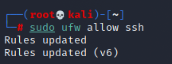

sudo ufw allow http

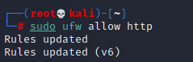

sudo ufw allow https

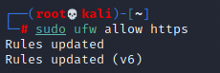

sudo ufw allow 443

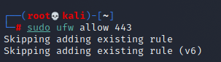

ufw status verbose

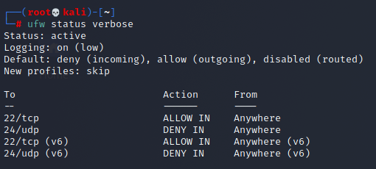

systemctl start ufw

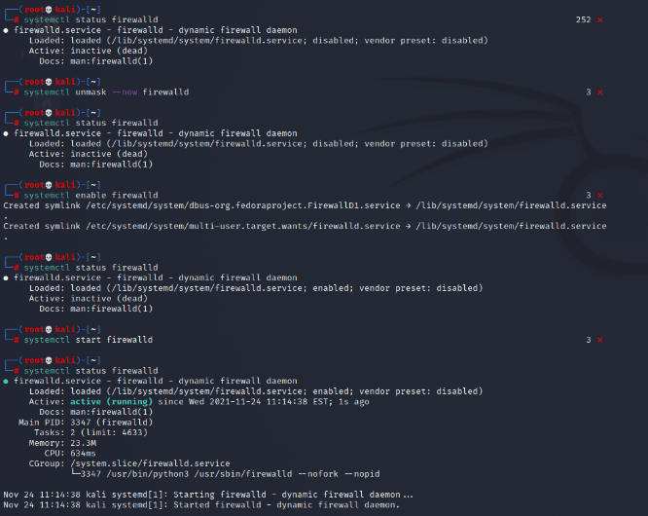



sudo ufw allow proto tcp from any to any port 80,443

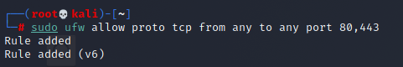

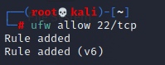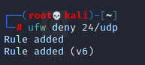

grep VERSION /etc/os-release

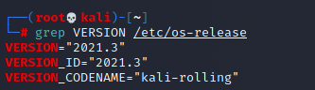

firewall-cmd --get-services

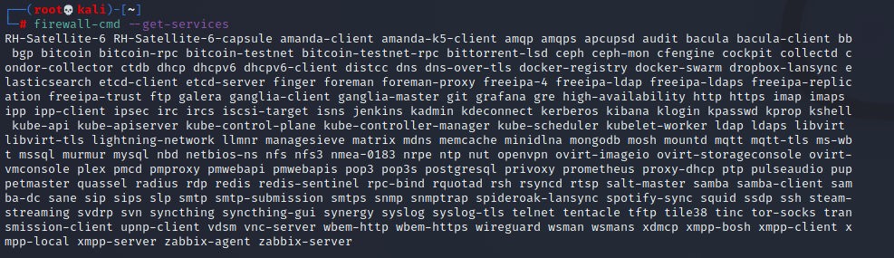

firewall-cmd --zone=external --list-all

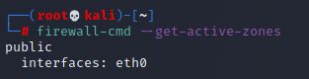

firewall-cmd --set-default=external



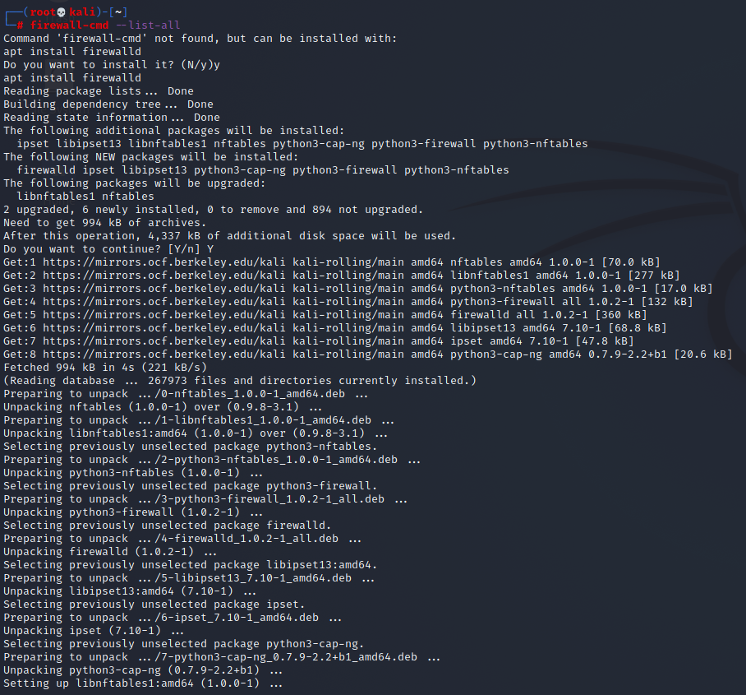

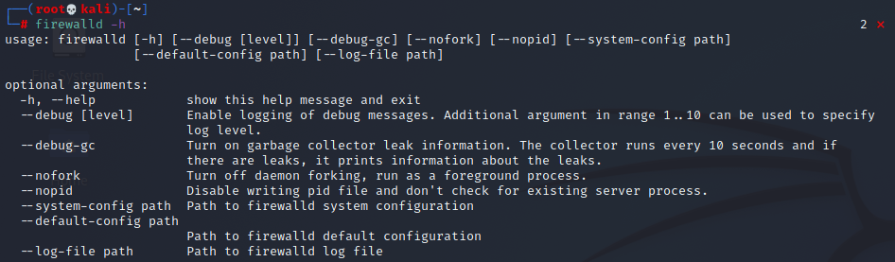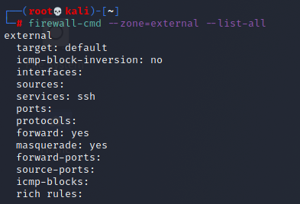

IP TABLES OPERATIONS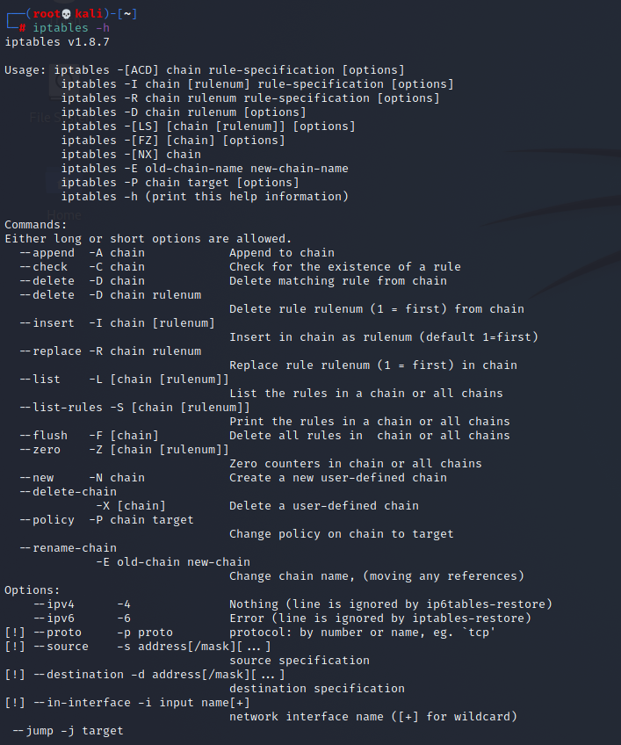

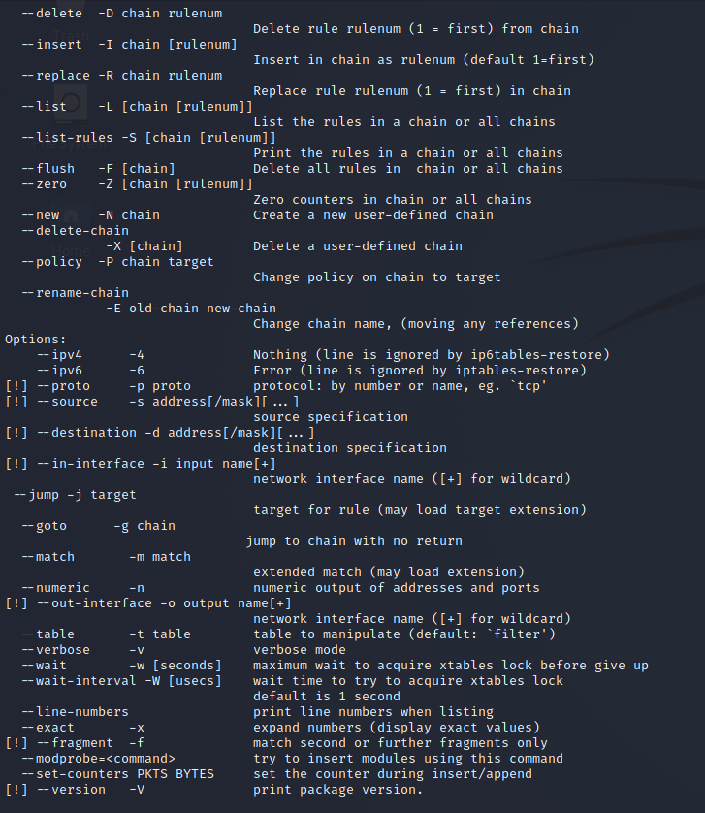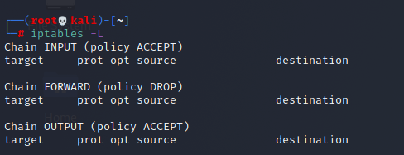

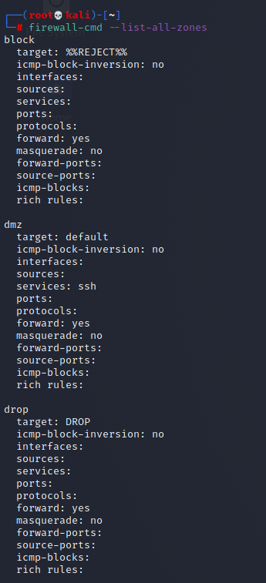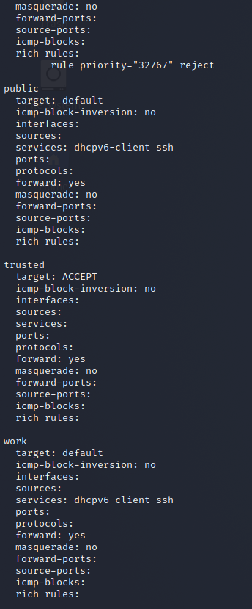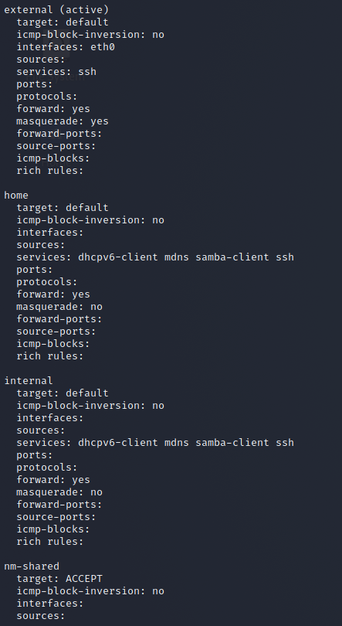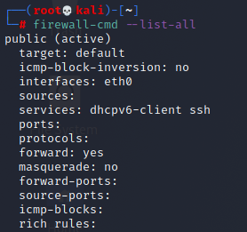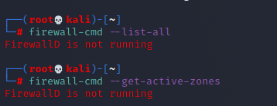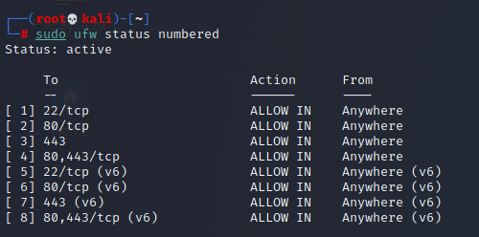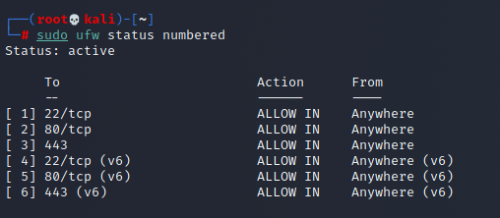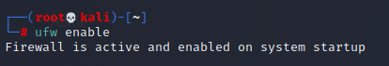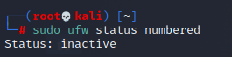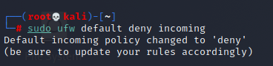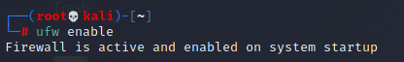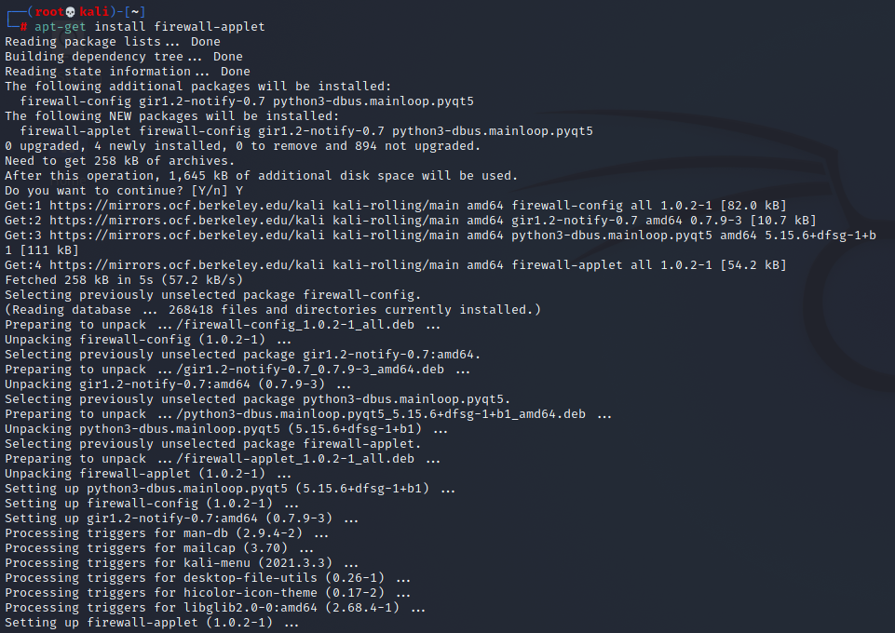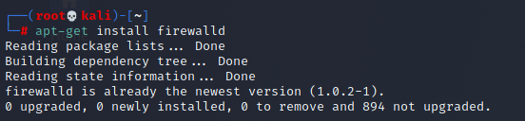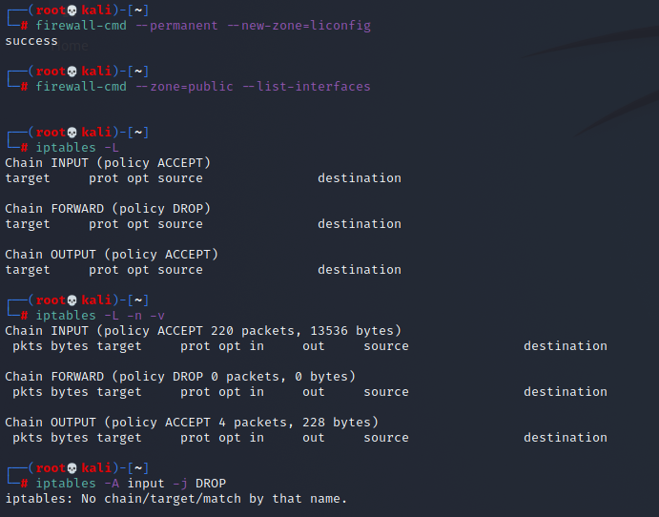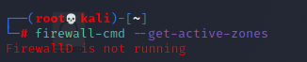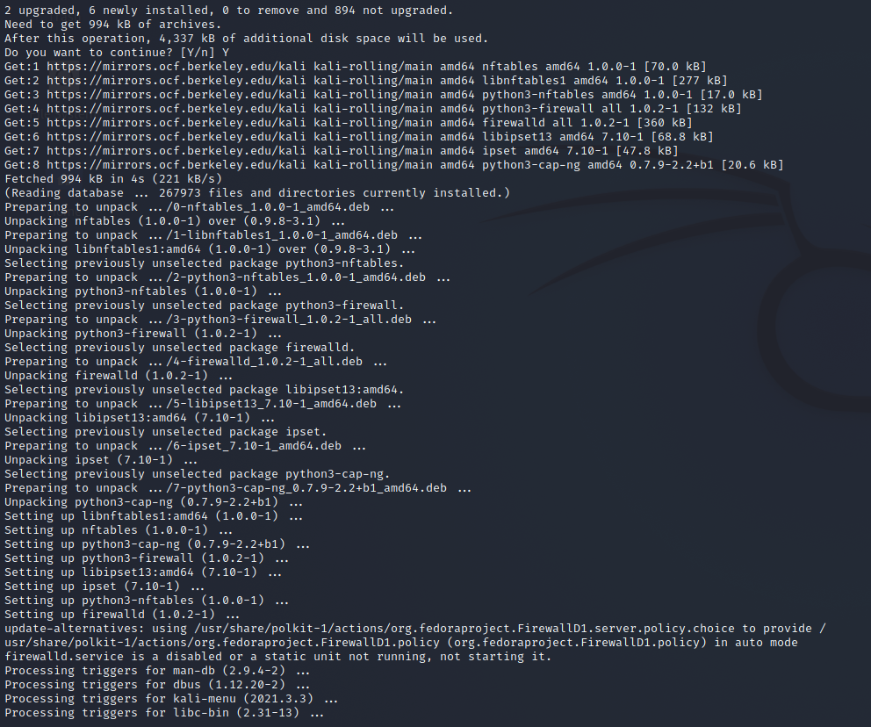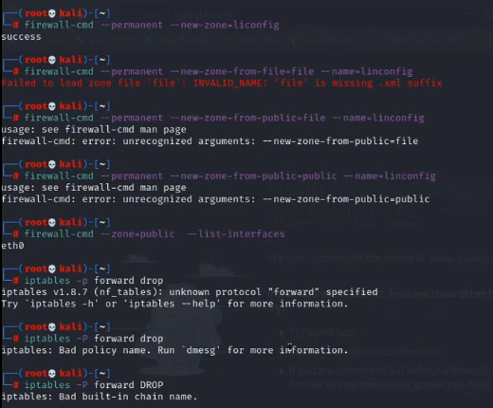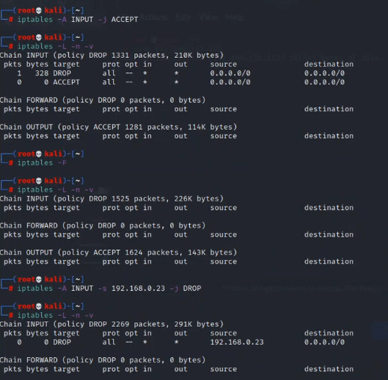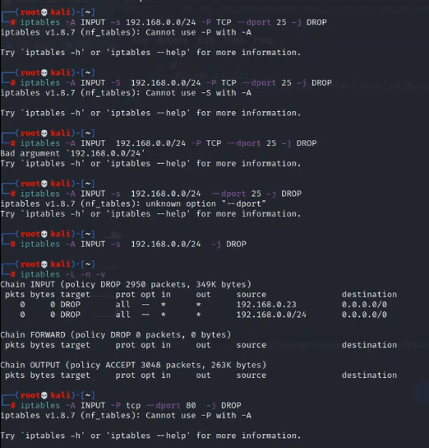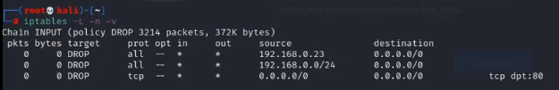

Remember that you can check your current UFW ruleset with sudo ufw status or sudo ufw status verbose.

Allow Incoming Connections to a Network Interface

To allow incoming connections from a specific IP address to a specific network interface, run the following command, replacing the highlighted IP address with the IP address you want to allow:

sudo ufw allow in on eth0 from 203.0.113.102

Rule added

The in parameter tells ufw to apply the rule only for **incoming** connections, and the on eth0 parameter specifies that the rule applies only for the eth0 interface.

If you run sudo ufw status now, you’ll see similar to this:

Status: active

To Action From

-- ------ ----

...

Anywhere on eth0 ALLOW 203.0.113.102

List Available Application Profiles

Upon installation, applications that rely on network communications will typically set up a UFW profile that you can use to allow connection from external addresses. This is often the same as running ufw allow from, with the advantage of providing a shortcut that abstracts the specific port numbers a service uses and provides a user-friendly nomenclature to referenced services.

To list which profiles are currently available, run the following:

sudo ufw app list

If you installed a service such as a web server or other network-dependent software and a profile was not made available within UFW, first make sure the service is enabled. For remote servers, you’ll typically have OpenSSH readily available:

Available applications:

OpenSSH

Enable Application Profile

To enable a UFW application profile, run ufw allow followed by the name of the application profile you want to enable, which you can obtain with a sudo ufw app list command. In the following example, we’re enabling the OpenSSH profile, which will allow all incoming SSH connections on the default SSH port.

sudo ufw allow “OpenSSH”

Rule added

Rule added (v6)

Remember to quote profile names that consist of multiple words, such as Nginx HTTPS.

Disable Application Profile

To disable an application profile that you had previously set up within UFW, you’ll need to remove its corresponding rule. For example, consider the following from sudo ufw status:

sudo ufw status

Status: active

To Action From

-- ------ ----

OpenSSH ALLOW Anywhere

Nginx Full ALLOW Anywhere

OpenSSH (v6) ALLOW Anywhere (v6)

Nginx Full (v6) ALLOW Anywhere (v6)

This indicates that the Nginx Full application profile is currently enabled, allowing any and all connections to the web server both via HTTP as well as via HTTPS. If you’d want to only allow HTTPS requests from and to your web server, you’d have to first enable the most restrictive rule, which in this case would be Nginx HTTPS, and then disable the currently active Nginx Full rule:

sudo ufw allow "Nginx HTTPS"

sudo ufw delete allow "Nginx Full"

Remember you can list all available application profiles with sudo ufw app list.

Conclusion

UFW is a powerful tool that can greatly improve the security of your servers when properly configured. This reference guide covers some common UFW rules that are often used to configure a firewall on Ubuntu.

Most of the commands in this guide can be adapted to fit different use cases and scenarios, by changing parameters such as the source IP address and/or destination port. For more detailed information about each command parameter and available modifiers, you can use the man utility to check UFW’s manual:

**iptables** is a command line interface used to set up and maintain tables for the Netfilter firewall for IPv4, included in the Linux kernel. The firewall matches packets with rules defined in these tables and then takes the specified action on a possible match.

* *Tables* is the name for a set of chains.
* *Chain* is a collection of rules.
* *Rule* is condition used to match packet.
* *Target* is action taken when a possible rule matches. Examples of the target are ACCEPT, DROP, QUEUE.
* *Policy* is the default action taken in case of no match with the inbuilt chains and can be ACCEPT or DROP.

**Syntax:**

iptables --table *TABLE* -A/-C/-D... *CHAIN* *rule* --jump *Target*

**TABLE**

There are five possible tables:

* **filter:** Default used table for packet filtering. It includes chains like INPUT, OUTPUT and FORWARD.
* **nat :** Related to Network Address Translation. It includes PREROUTING and POSTROUTING chains.
* **mangle :** For specialised packet alteration. Inbuilt chains include PREROUTING and OUTPUT.
* **raw :** Configures exemptions from connection tracking. Built-in chains are PREROUTING and OUTPUT.
* **security :** Used for [Mandatory Access Control](https://en.wikipedia.org/wiki/Mandatory_access_control)

**CHAINS**

There are few built-in chains that are included in tables. They are:

* **INPUT :**set of rules for packets destined to localhost sockets.
* **FORWARD :**for packets routed through the device.
* **OUTPUT :**for locally generated packets, meant to be transmitted outside.
* **PREROUTING :**for modifying packets as they arrive.
* **POSTROUTING :**for modifying packets as they are leaving.

**Note:** User-defined chains can also be created.

**OPTIONS**

1. **-A, –append :** Append to the chain provided in parameters.

**Syntax:**

iptables [-t table] --append [chain] [parameters]

**Example:** This command drops all the traffic coming on any port.

iptables -t filter --append INPUT -j DROP

**Syntax:**

iptables [-t table] --delete [chain] [rule_number]

**Example:** This command deletes the rule 2 from INPUT chain.

iptables -t filter --delete INPUT 2

1. **-C, –check :**Check if a rule is present in the chain or not. It returns 0 if the rule exists and returns 1 if it does not.

**Syntax:**

iptables [-t table] --check [chain] [parameters]

**Example:** This command checks whether the specified rule is present in the INPUT chain.

iptables -t filter --check INPUT -s 192.168.1.123 -j DROP

**Output:**

**PARAMETERS**

The parameters provided with the *iptables*command is used to match the packet and perform the specified action. The common parameters are:

1. **-p, –proto :** is the protocol that the packet follows. Possible values maybe: tcp, udp, icmp, ssh etc.

**Syntax:**

iptables [-t table] -A [chain] -p {protocol_name} [target]

**Example:** This command appends a rule in the INPUT chain to drop all udp packets.

iptables -t filter -A INPUT -p udp -j DROP

1. **-s, –source:** is used to match with the source address of the packet.

**Syntax:**

iptables [-t table] -A [chain] -s {source_address} [target]

**Example:** This command appends a rule in the INPUT chain to accept all packets originating from 192.168.1.230.

iptables -t filter -A INPUT -s 192.168.1.230 -j ACCEPT

**Output:**

1. **-d, –destination :** is used to match with the destination address of the packet.

**Syntax:**

iptables [-t table] -A [chain] -d {destination_address} [target]

**Example:** This command appends a rule in the OUTPUT chain to drop all packets destined for 192.168.1.123.

iptables -t filter -A OUTPUT -d 192.168.1.123 -j DROP

1. **-i, –in-interface :** matches packets with the specified in-interface and takes the action.

**Syntax:**

iptables [-t table] -A [chain] -i {interface} [target]

**Example:** This command appends a rule in the INPUT chain to drop all packets destined for wireless interface.

iptables -t filter -A INPUT -i wlan0 -j DROP

**Output:**

1. **-o, –out-interface :** matches packets with the specified out-interface.
2. **-j, –jump :** this parameter specifies the action to be taken on a match.

**Syntax:**

iptables [-t table] -A [chain] [parameters] -j {target}

**Example:** This command adds a rule in the FORWARD chain to drop all packets.

iptables -t filter -A FORWARD -j DROP

**Note:**

* While trying out the commands, you can remove all filtering rules and user created chains.
* sudo iptables --flush
* To save the iptables configuration use:

sudo iptables-save

* Restoring iptables config can be done with:

sudo iptables-restore

* There are other interfaces such ip6tables which are used to manage filtering tables for IPv6.

Firewalls are a vital part of network security, so it’s important for a sysadmin to be familiar with how they work. If you understand firewalls, you can keep your network secure by making intelligent choices about the traffic you allow in and out.

Because "firewall" is such an exciting name, people often imagine an intricate Tron-style neon battle happening on the outskirts of a network, with packets of rogue data being set alight to protect your users’ the techno fortress. In reality, a firewall is just a piece of software controlling incoming and outgoing network traffic.

## Ports

A firewall is able to manage this traffic by monitoring network ports. In the world of firewalls, the term port doesn’t refer to a physical connection like a USB, VGA, or HDMI port. For the purpose of firewalls, a port is an artificial construct created by the operating system to represent a pathway for a specific type of data. This system could have been called anything, like "contacts," "connections," or even "penguins," but it the creators used "ports," and that’s the name that we still use today. The point is, there’s nothing special about any port; they are just a way to designate an address where data transference happens.

There are a number of ports that are well-known, but even these are only conventions. For instance, you may know that HTTP traffic occurs on port 80, HTTPS traffic uses port 443, FTP uses port 21, and SSH uses port 22. When your computer transmits data to another computer, it adds a prefix to the data to indicate which port it wants to access. If the port on the receiving end is accepting data of the same protocol as the data you are sending, then the data is successfully exchanged.

You can see this process in action by going to any website. Open a web browser and navigate to example.com:80, which causes your computer to send an HTTP request to port 80 of the computer serving the example.com website. You receive a webpage in return. Web browsers don’t require you to enter the port you want to access every time you navigate to a URL, however, because it’s assumed that HTTP traffic accesses port 80 or 443.

You can test this process using a terminal-based web browser:

**$** curl --connect-timeout 3 "http://example.com:80" | head -n4

<!doctype html>

<html>

<head>

<title>Example Domain</title>

Using the same notation, you can force rejection by navigating to a website using a nonstandard port. Navigate to an arbitrary port, example.com:79 for instance. Your request for a webpage is declined:

**$** curl --connect-timeout 3 "http://example.com:79"

curl: (7) Failed to connect: Network is unreachable

The correlation between ports and protocols are merely conventions mutually agreed upon by a standards group, and a user base. These settings can be changed on individual computers. In fact, back in the pioneer days of computing, many people felt that just changing the port number of popular services would allay an attack. Today, attacks are a lot more sophisticated. There’s little value in surprising an automated port scanner by changing which port a service listens on.

Instead, a firewall governs what activity is permitted on any given port.

## The firewall-cmd interface

Your infrastructure may have a server in a rack with the sole purpose of running a firewall, or you may have a firewall embedded in the router—or modem—acting as your primary gateway to the internet. You probably also have a firewall running on your personal workstation or laptop. All of these firewalls have their own configuration interface. This article covers the firewall-cmd terminal command found on most Linux distributions.

Firewall-cmd is a front-end tool for managing the firewalld daemon, which interfaces with the Linux kernel’s netfilter framework. This stack probably isn’t present on the embedded modems common in small- to medium-sized businesses, but it’s on or available for any Linux distribution that uses systemd.

Without an active firewall, firewall-cmd has nothing to control, so the first step is to ensure that firewalld is running:

**$** sudo systemctl enable --now firewalld

This command starts the firewall daemon and sets it to auto-load upon reboot.

### Block (almost) everything

Common advice when configuring a firewall is to first block everything, and then open the ports you know you actually need. That means you have to know what you need, though, and sometimes figuring that out is an afternoon’s job all its own.

If your organization runs its own DNS or DNS caching service, for instance, then you must remember to unblock the port (usually 53) handling DNS communication. If you rely on SSH to configure your servers remotely, then you must not block that port. You must account for every service running on your infrastructure, and you must understand whether that service is internal-only or whether it needs to interact with the outside world.

In the case of proprietary software, there may be calls made to the outside world that you’re not even aware of. If some applications react poorly to a strict firewall recently put in place, you may have to reverse engineer (or talk to the application’s support line) to discover what kind of traffic it’s trying to create, and why. In the open source world, this issue is less common, but it’s not outside the realm of possibility, especially in the case of complex software stacks (for example, today even media players make calls out to the internet, if only to fetch album art or a track listing).

Firewall-cmd uses zones as presets, giving you sane defaults to choose from. Doing this saves you from having to build a firewall from scratch. Zones apply to a network interface, so on a server with two ethernet interfaces, you may have one zone governing one ethernet interface, and a different zone governing the other.

It’s worth taking time to get familiar with the zones provided on your system. To see all available zones, use:

**$** sudo firewall-cmd --get-zones

block dmz drop external home internal public trusted work

To see what’s unblocked in a specific zone:

**$** sudo firewall-cmd --zone work --list-all

work

target: default

icmp-block-inversion: no

interfaces: ens3

sources:

services: cockpit dhcpv6-client ssh

ports:

protocols:

masquerade: no

forward-ports:

source-ports:

icmp-blocks:

rich rules:

Use one of the existing zones as a starting point for your own firewall rules, or just create your own.

### Create a zone

To create a new zone, use the --new-zone option.

All firewall-cmd actions persist only until the firewall or the computer running it restarts. Anything you want to be permanent must be accompanied by the --permanent flag.

For an example, create a new permanent zone called corp, and then reload the firewall rules so that your new zone activates:

**$** sudo firewall-cmd --new-zone corp --permanent

success

**$** sudo firewall-cmd --reload

Before assigning any network interface to this new zone, add the ssh service so you can access it remotely. Use the --permanent option to make this addition persist across reboots:

**$** sudo firewall-cmd --zone corp --add-service ssh --permanent

Your new zone, called corp, is now active, rejects all but SSH traffic, and is assigned to no specific network interface. To make corp the active and default zone for the network interface you want to protect (ens3 in this example), use the --change-interface option:

**$** firewall-cmd --change-interface ens3 \

--zone corp --permanent

The interface is under control of NetworkManager, setting zone to 'corp'.

success

By making corp the default zone, all future commands are applied to corp unless the --zone option specifies a different zone. Whether you want to set corp as the default depends on whether you plan to this zone as your new primary zone. If so, the following does the job:

**$** sudo firewall-cmd --set-default corp

To view the zones currently assigned to each interface, use the --get-active-zones option:

**$** sudo firewall-cmd --get-active-zones``

corp

interfaces: ens3

work

interfaces: ens4

### Add and remove services

Now that you’ve blocked everything but SSH, you can open the ports your network relies upon. The quick and easy way to permit traffic through your firewall is to add a predefined service.

The list of available predefined services is extensive. To view it, use:

**$** sudo firewall-cmd --get-services

RH-Satellite-6 amanda-client amqp

amqps apcupsd audit bacula bacula-client

bgp bitcoin bitcoin-rpc bitcoin-testnet ceph

cockpit dhcp dhcpv6 dhcpv6-client distcc dns

[...]

Assume you need to run a webserver. First, you would install the webserver you want to use (the httpd package on RHEL or Fedora, apache2 on Ubuntu and Debian). For this example, we’ll use httpd:

**$** sudo dnf install httpd

**$** sudo systemctl --enable --now httpd

Then, test your webserver locally:

**$** curl --silent localhost:80 | grep title

<title>Test Page for the Apache HTTP Server on Red Hat Enterprise Linux</title>

Next, attempt to connect to your webserver from an external browser. The connection fails, demonstrating that the firewall is effective:

**$** curl --connect-timeout 3 192.168.122.206

curl: (28) Connection timed out after 3001 milliseconds

Unblock a service

To permit HTTP traffic through your firewall, add the http service:

**$** sudo firewall-cmd --add-service http --permanent

**$** sudo firewall-cmd --reload

Then, test from an outside source:

**$** curl --silent 192.168.122.206 | grep title

<title>Test Page for the Apache HTTP Server on Red Hat Enterprise Linux</title>

Now that you know how to add a service, removing one is fairly intuitive:

**$** sudo firewall-cmd --remove-service http --permanent

**$** sudo firewall-cmd --reload

Add and remove ports

Sometimes, a predefined service doesn’t exist, or it assumes defaults that don’t match your network. Instead of adding a service, you can add a port number and protocol type directly with --add-port.

For instance, if you need to add the non-standard port 1622 for SSH to your custom zone (if your custom zone isn’t the default zone for your commands, add the --zone option):

**$** sudo firewall-cmd --add-port 1622/tcp --permanent

success

**$** sudo firewall-cmd --reload

To remove that port, use --remove-port:

**$** sudo firewall-cmd --remove-port 1622/tcp --permanent

success

**$** sudo firewall-cmd --reload